# Запросы к базе данных

1. Первое задание:

SELECT c.login, count(o.id)

FROM "Couriers" AS c

INNER jJOIN "Orders" AS o ON c.id=o."courierId"

WHERE o."inDelivery"='t'

GROUP BY c.login;

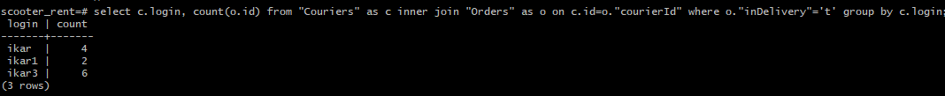

1. Второе задание

SELECT track,

CASE

WHEN finished='t' THEN '2'

WHEN cancelled = 't' THEN '-1'

WHEN "inDelivery" = 't' THEN '1'

ELSE ‘0’

END AS status_track

FROM "Orders";

